Hack-A-Jeep Documentation

1. First Hack (Sharon, Saad, Dona, Hannah) -------------------------------------------- 2
2. Second Hack (Shi En, Hannah) ---------------------------------------------------------- 4
3. Further work--------------------------------------------------------------------------------- 6
4. First Hack (Sharon, Saad, Dona, Hannah)

Pin Connections (rows connected)

|  |  |  |  |  |
| --- | --- | --- | --- | --- |
| Arduino | L298 | Relay | Buttons | Original Car Controller |
| 2 | IN D |  |  |  |
| 3 | IN C |  |  |  |
| 4 |  | IN 1 (relay 2) |  |  |
| 5 |  | IN 2 (relay 2) |  |  |
| 6 |  | IN 3 (relay 2) |  |  |
| 7 |  | IN 4 (relay 2) |  |  |
| 8 | EN A |  |  |  |
| 9 | EN B |  |  |  |
| 10 |  |  |  |  |
| 11 | IN B |  |  |  |
| 12 | IN A |  |  |  |
| 13 |  |  |  |  |
| 5v | 5v x2 | 5v | Red Wire in |  |
| GND | GND | GND | Black Wire in |  |
| A0 |  |  | Forward Button |  |
| A1 |  |  | Back Button |  |
| A2 |  |  | Left Button |  |
| A3 |  |  | Right Button |  |
| A4 |  |  |  |  |
| A5 – Jumper to GND |  |  |  |  |
|  |  |  |  | A (Battery x2 7.4v) |
|  |  |  |  | B (Rear wheel motor x2) |
|  |  |  |  | C (Steering motor) |
|  |  |  |  | D (Pedal, Stick, lights) |
|  | A and B Motor out connected in parallel |  |  |  |

Relay Connections

* Label
* Wire Color
* Purpose

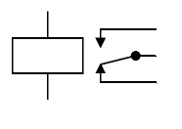

Black

L298 Out

Black

Steering Motor (C)

Black

Original Controller Connector (C)



Red

L298 Out

Brown

Steering Motor (C)

Red

Original Controller Connector (C)

Relay: IN2

Relay: IN1



Black

Pedal

Red

Pedal



F

White

Stick Forward

O

Red

Stick Neutral

B

Stick Back

Relay: IN4

Relay: IN3

Connector D (Original Controller)

|  |  |  |  |  |  |  |
| --- | --- | --- | --- | --- | --- | --- |
| Color | Yellow | Orange | Blue | Black | White | Red |
| Marking |  | Center | Back |  | Forward |  |

Second Hack (Shi En, Hannah)

Pin Connections

|  |  |  |  |
| --- | --- | --- | --- |
| Arduino | Relay | Buttons | Bluetooth |
| 2 | IN 1 |  |  |
| 3 | IN 2 |  |  |
| 4 | IN 3 |  |  |
| 5 | IN 4 |  |  |
| 6 |  | Forward |  |
| 7 |  | Backward |  |
| 8 |  | Left |  |
| 9 |  | Right |  |
| 10 |  |  | TX pin |
| 5v | 5v | 5v (Red) | 5v in (regulator) |
| Gnd | Gnd | Gnd (black) | Gnd |

Relay Connections



12V

Red

Steer Motor (C)

Gnd

Relay: IN2



12V

Red

Steer Motor (C)

Gnd

Relay: IN1



12V

Black

Rear Motor (B)

Gnd

Relay: IN4



12V

Red

Rear Motor (B)

Gnd

Relay: IN3

Bluetooth

App: Joy BT Commander

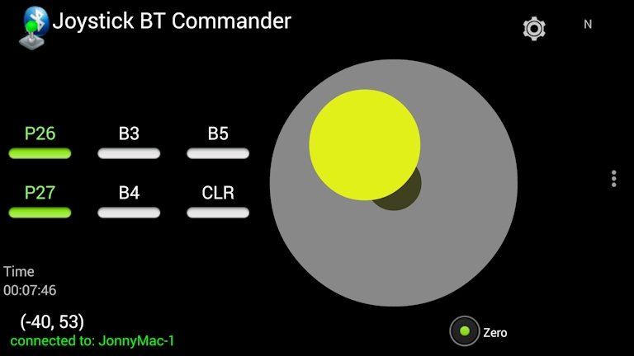

Select

1. Factory settings: Settings – reset Opt.
2. Connect Bluetooth: Connect – Select HC-05
   1. (if not found, go to Bluetooth settings, forget existing bindings)

Button Wire

Holes drilled to route wire from undercarriage to hole at steering wheel.

Batteries

2x 7.4 Lead Acid batteries were damaged from undercharging, and was replaced with a 12v Lead Acid battery.

Code:

<https://github.com/Shine16/HackAJeep>

Further work

Add Speed control from Batteries to motors, currently too fast. Possible solutions:

* Knob PWM Spindle controller
* L298 and PWM from Arduino
* 150w Buck converter, reduce voltage from batt to relays

Complete installation of:

* Power ON/OFF switch
  + Do test of max power for
* Button/Button+BLE Control mode switches
  + Mode 1: Buttons only
  + Mode 2: Buttons and BLE override
  + Mode 3: Stick and Pedal only

Implement Timers to smoothern BLE Code

External Leads by screws for connecting 12v lead acid charger to battery

New Button mounting, possibly 3d print and fit to squarish fitting in front of car